**ASR 5012 new shipping label and Carton content label for TGCS storer**

Date: 29 Jan 2015

Estimated Live date: 1 March 2015

--=========================================================================

**From:** Fabian Cheong [<mailto:fabian@sg.ibm.com>]  **Sent:** Monday, January 26, 2015 10:15 AM **To:** Lee, David; Mervyn, Tan; [ibmstc-outbound@dbschenker.com](mailto:ibmstc-outbound@dbschenker.com) **Subject:** New Label settings   
  
Dear All,   
  
TGCS transition will go live on 1st March 2015. This means that TGCS operations will be standalone and no longer be under IBM.   
As such, TGCS will have some changes to the way we will support in terms of operations.   
  
I need your help to review the labels below, and advise if you can print out from your WMS system in the below format?   
 **Best Regards**  **Fabian Cheong**  **Global Logistics – Singapore   
Geodis Supply Chain Optimisation   
Phone: +65 6603 7920 (Office)**  **Phone: +65 6214 3684 (Warehouse)  
E-mail:** [**fabian@sg.ibm.com**](mailto:9leej@sg.ibm.com) **[attachment "Current_TGCS_shipping Label_20150123.pdf" deleted by Fabian Cheong/Singapore/Geodis/IDE]**

--=========================================================================

**Request Description:**

Require new shipping label printing for Storer TGCS (Toshiba), every scanned of Carton require system to print out 1 shipping label and 1 carton content label.

Label size for both: 4x6 inch

Notes: after TGCS transition, no changes to current inbound and outbound creation process and inventory capture.

# Shipping Label:

## Sample format

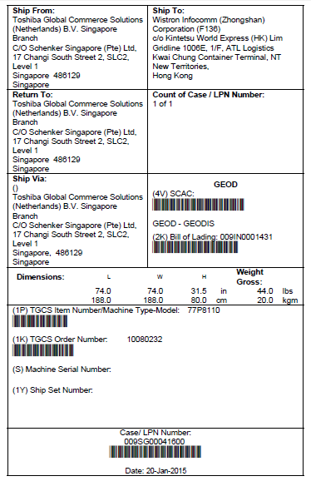

|  |  |  |  |  |
| --- | --- | --- | --- | --- |
| **S/N** | **Label field name** | **Label Field length** | **WMS Field** | **Detail Mapping** |
| 1 | Ship From |  |  | No change – current storer addresses |
| 2 | Return to: |  |  | New add - Address Same as “Ship From” |
| 3 | Ship Via |  |  | New add - Address Same as “Ship From” |
| 4 | Ship to |  |  | No change – current ship to address |
| 5 | Count of Case |  |  | New add – carton count |
| 6 | (4V) SCAC | Char 13 | ORDERS.CC_CarrierKey Char(20) | New add field: SCAC  SCAC is the Carrier name and not fixed, below are the 2 main selections that will be use.  Max length should be 13  GEOD - GEODIS  UPS - UPS  To add system code lookup values- |
| 7 | (2K) Bill of Lading | Char 12 | Orders.Externorderkey | New shipping document reference # from Toshiba.  (to replaced current IBM Packing list # )  Eg>009IN0001409 |
| 8 | Dimension |  |  | Carton dimension (BAX_ScanPackDetail.Length, BAX_ScanPackDetail.Width, BAX_ScanPackDetail.Height) |
| 9 | Weight gross |  |  | Carton gross weight  BAX_ScanPackDetail.Grosswgt |
| 10 | (1P) TGCS Item number |  |  | Part Number (SKU) |
| 11 | TGCS Order number | Char 12 | ORDERS.PlantNumber  Char(20) | New field – TGCS SO number  Eg. 10094460 |
| 12 | (S) Machine Serial Number |  | Outbound: OrderDetail.altsku | ** field not applicable currently  Inbound: Mapping to Serial No. in Hub-Inbound  WMS – Receiptdetail.altsku, field length 20 |
| 13 | (1Y) Ship Set Number |  | Outbound : Orderdetail.RetailSKU | ** field not applicable currently  Inbound Mapping to Reference2  Mapping to WMS – Receiptdetail.Reference2, field length 20 |
| 14 | Case/LPN Number |  |  | No change, Carton LP # |
| 15 | Date |  |  | Current print date |

WMS-Inbound Detail:



WMS – Outbound Order Creation

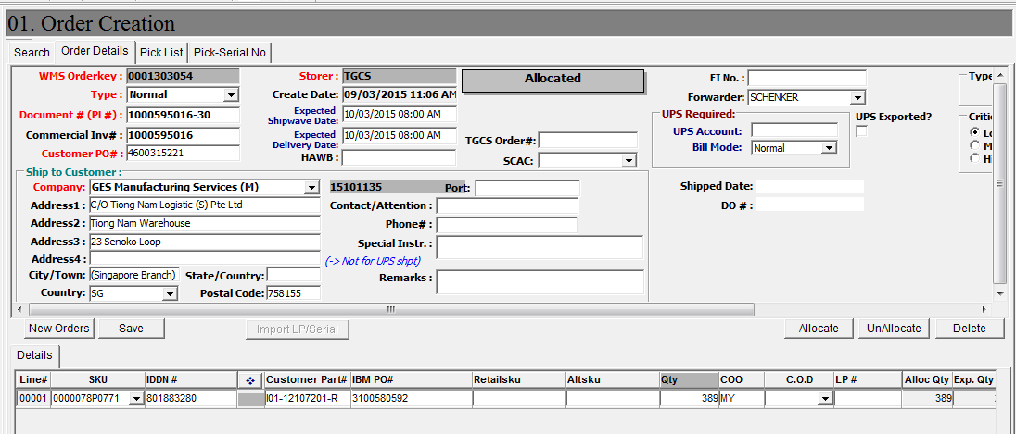

# Carton Content label:

## **Sample label**

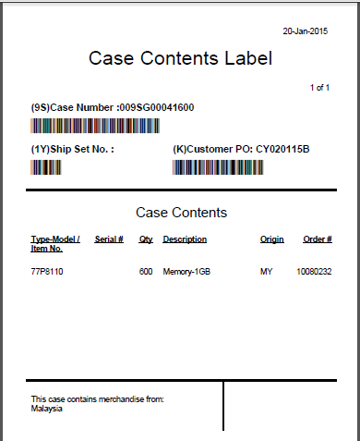

Field Mapping:

|  |  |  |  |  |
| --- | --- | --- | --- | --- |
| **S/N** | **Label field name** | **Label Field length** | **WMS Field** | **WMS Mapping** |
| 1 | Date |  |  | Current print date |
| 2 | Page |  |  | Page number and page count |
| 3 | (9S) Case Number |  |  | No change, carton LP # |
| 4 | (1Y) Ship Set No. |  | Outbound : Orderdetail.RetailSKU  Char(20) | New, but not applicable field currently in WMS-TGCS. |
| 5 | (K) Customer PO: |  |  | No Change , customer PO# |
| 6 | Type-Model /Item No |  |  | Part Number (SKU) |
| 7 | Serial # |  | Outbound : Orderdetail.AltSKU  Char(20) | New, but not applicable field currently in WMS-TGCS. |
| 8 | Qty |  |  | Order qty |
| 9 | Description |  |  | Part description SKU.Descr |
| 10 | Origin |  | Orderdetail.origincountry | no change, existing field  Use Country Code. |
| 11 | Order # |  | Orders.PlantNumber | New field. TGCS SO number |
| 12 | This case contains merchandise from: |  |  | Existing use the Origin country name description |

WMS CHANGES:

Date: 6 Feb 2014

HUB-Order creation

TGCS – Sales Order#,

SCAC

TGCS - Bill of Lading

